**ALL INDIA SENIOR SECONDARY SCHOOL**

**CERTIFICATE EXAMINATION**

2017-2018

**A**

**PROJECT REPORT**

**ON**

"Bank Management System“

**SUBMITED TO: SUBMITED BY:**

Mr. Hitesh Goyal  **Khushdeep Tanwar**

HOD Computer Science CLASS -: XII

Blue Bells Model School ROLL NO-2632454

Gurgaon 122001

**BLUE BELLS MODEL SCHOOL**

(Affiliated to CBSE, New Delhi - No. 0530056)

SEC-4 GURGAON

Date :

**C E R T I F I C A T E**

This is to certify that the investigatory project report entitled “ Bank Management System “ Submitted by Master Khushdeep Tanwar is original and has been completed by him/her under my supervision and is complete in all respect for AISSCE 2017 - 2018.

Hitesh Goyal

HOD Computer Sc.

# ACKNOWLEDGEMENT

# As a student of class XII I have selected the C++ application programming to develop my project on “Bank Management System” as a part of my studies during AISSCE 2017-2018.

**I owe a deep sense of gratitude to Mr. Hitesh Goyal whose constant help enabled me to complete my project work.**

**I am also very grateful to my parents and friends whose blessings were always there with me. A project cannot be facilitated by a single person so I with my friends worked on a same topic with different angles of imagination and logic and developed the project software.**

**Khushdeep Tanwar**

CLASS – XII

ROLL.NO-2632454

***INDEX***

1. Introduction / Overview of C++
2. Introduction of Project
3. Requirements of Hardware & Software
4. User Manual
   1. Header Files
   2. List of Data File with detailed information.
   3. Class & Objects
   4. functions
5. Source Code
6. Output Screen Shot
7. Bibliography
8. Enclosed: - Source Code CD with Output Screen shot and other contents.

### INTRODUCTION OF C++

The C++ programming language was developed at AT&T Bell laboratories in early 1980’s by ***Bajarne Stroustrup***. C++ is an object oriented programming (OOP) which offers the easy way to programming.

In 12 class we studied several topics as follows:-

1. FILE HANDLING
2. CONSTRUCTOR & DESRTRUCTOR
3. CLASS & OBJECTS
4. BOOLEAN ALGEBRA
5. ARRAY
6. DATA COMMUNICATION
7. STANDARD QUERY LANGUAGE
8. DATABASE
9. LINKED LIST

10.POINTERS

***INTRODUCTION OF PROJECT***

This project is developed by using C++ programming approach. This project describes the records of ***customer*** having a bank account. The project has been developed by using the file handling in C++ and the concept of OOPs, Class has been used to declare the data members and the function related to the data members. Data of the ***customer*** and all records related to ***customer***. Details of the ***customer*** taken in different files.

The main objective of making this project is to describe the technique of using files and their data with OOPs in C++ language.

***SOFTWARES & HARDWARES USED***

I have used several softwares like Microsoft office, Microsoft ***TC*** , notepad,

Windows. Hardwares like printers, key board, monitors, central processor unit

***USER MANUAL***

1. ***HEADER FILES***

1. #include<iostrem.h>

2. #include<fstream.h>

3. #include<stdio.h>

4. #include<ctype.h>

5. #include<conio.h>

6. #include<iomanip.h>

1. ***List of Data File with detailed information***

1.STUD.DAT

This file is used to enter the record of the student.

With the fields like registration no., name, address.

2.TEMP.DAT

This file is a temporary file to hold a record of stud .dat .

So, we can delete data from stud.dat.

3.MARK.DAT

This file used hold the marks of the particular subject of

Each student according to their registration no.

Like subject1.

1. ***Class & Objects***
2. ***Account()***

Class used to hold together all the operations that can be performedon the account

1. ***Functions***

1.void create_account();

function to get data from user

2.void show_account();

function to show data on screen

3.void modify();

function to get new data from user

4.void dep(int);

function to accept amount and add to balance amount

5.void draw(int);

function to accept amount and subtract from balance amount

6.void report();

function to show data in tabular format

7.void write_account();

function to write record in binary file

8.void display_sp(int);

function to display account details given by user

9.void modify_account(int);

function to modify record of file

10.void delete_account(int);

function to delete record of file

11.void display_all();

function to display all account details

12.void deposit_withdraw(int, int);

function to desposit/withdraw amount for given account

13.void intro(); //introductory screen function

***Output Screen Shots***

[SCREENSHOT1]

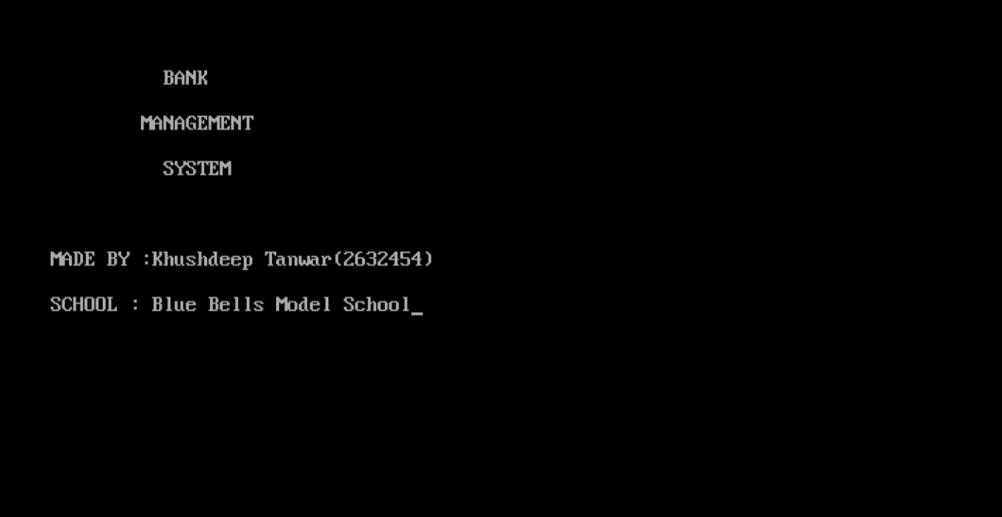

[SCREEN SHOT 2]

===========================================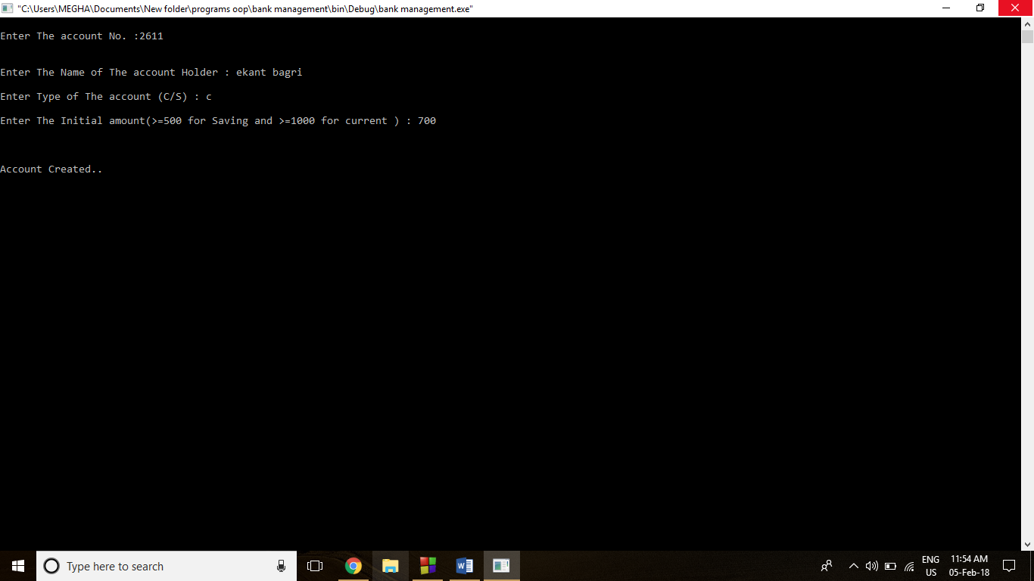=================

[SCREEN SHOT 3]

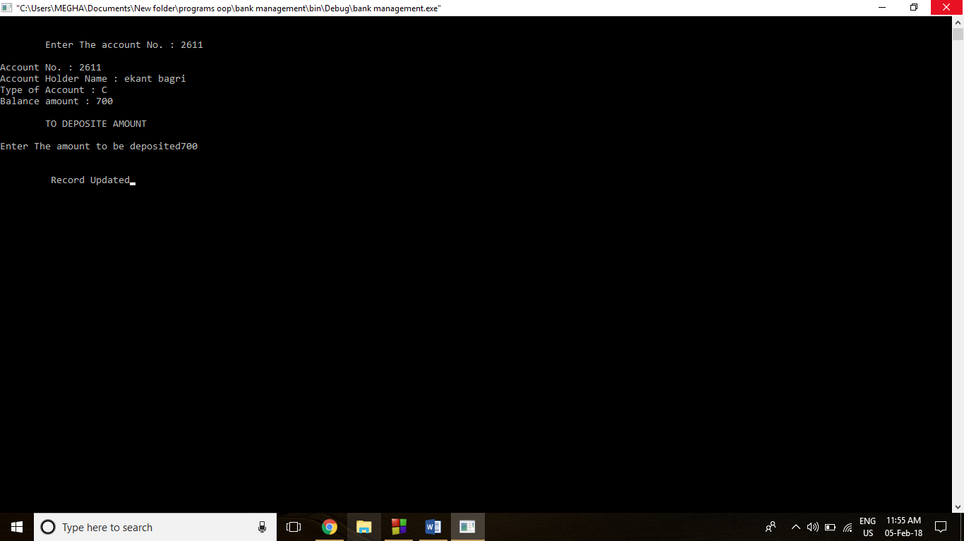

[SCREEN SHOTS 4]

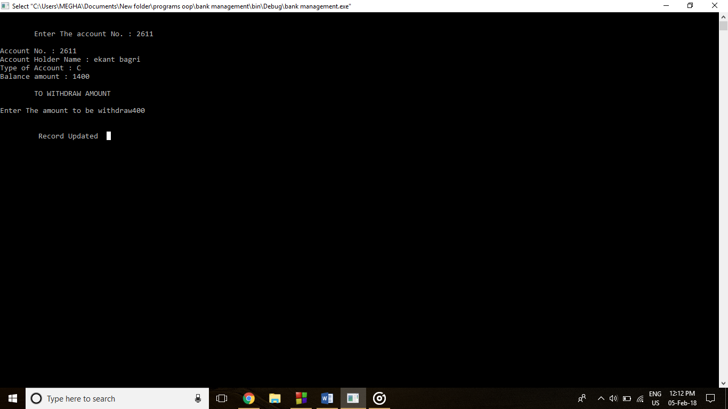

[SCREEN SHOT 5]

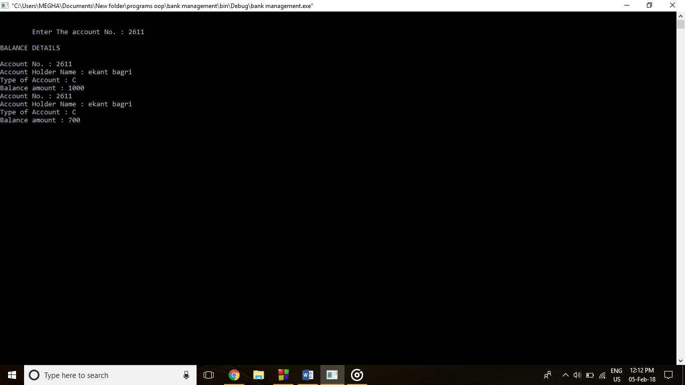

[SCREEN SHOT 6]

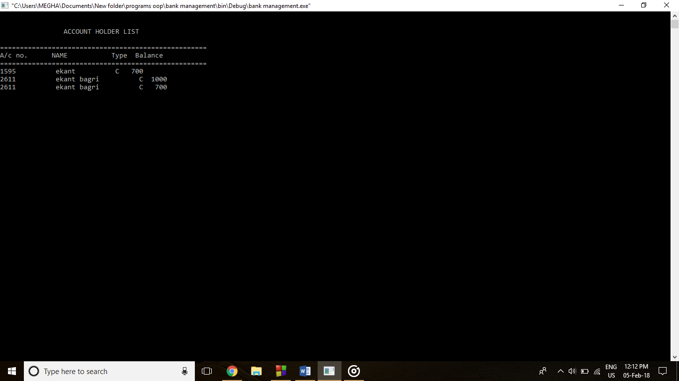

[SCREEN SHOT 7]

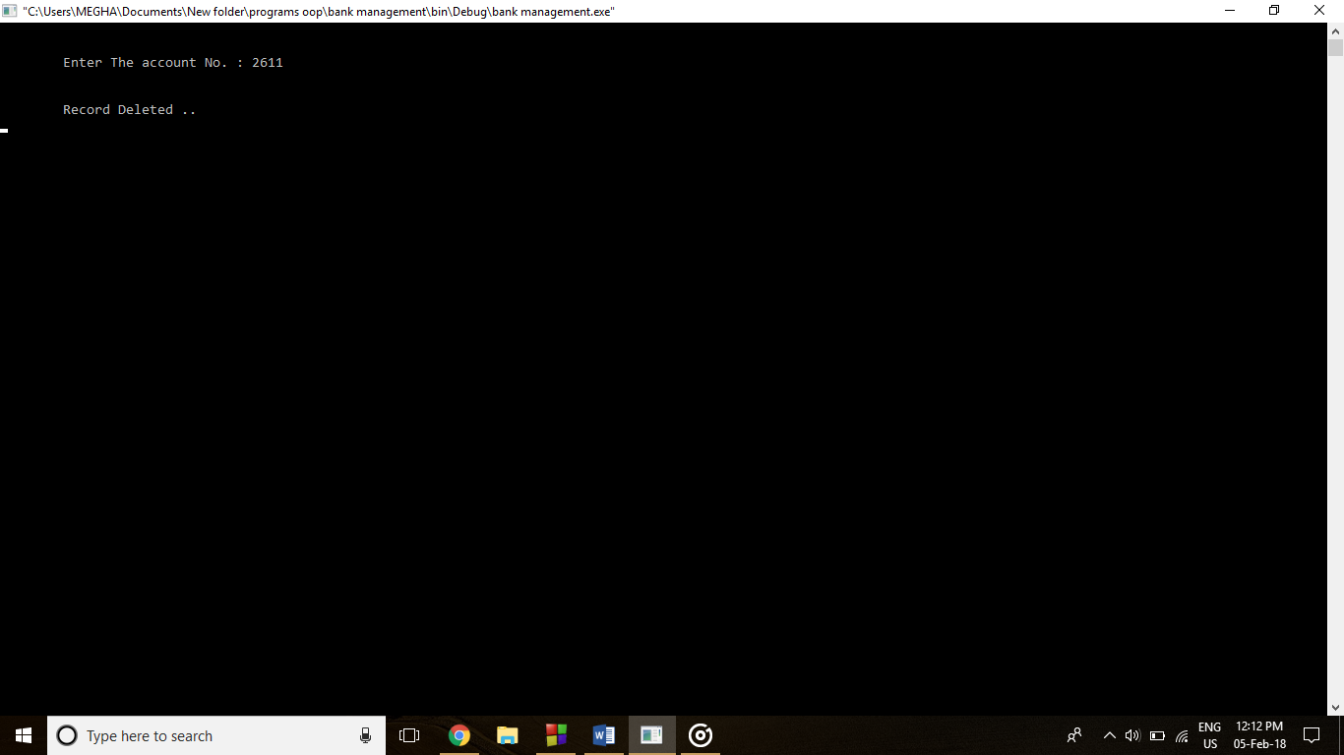

[SCREEN SHOT 8]

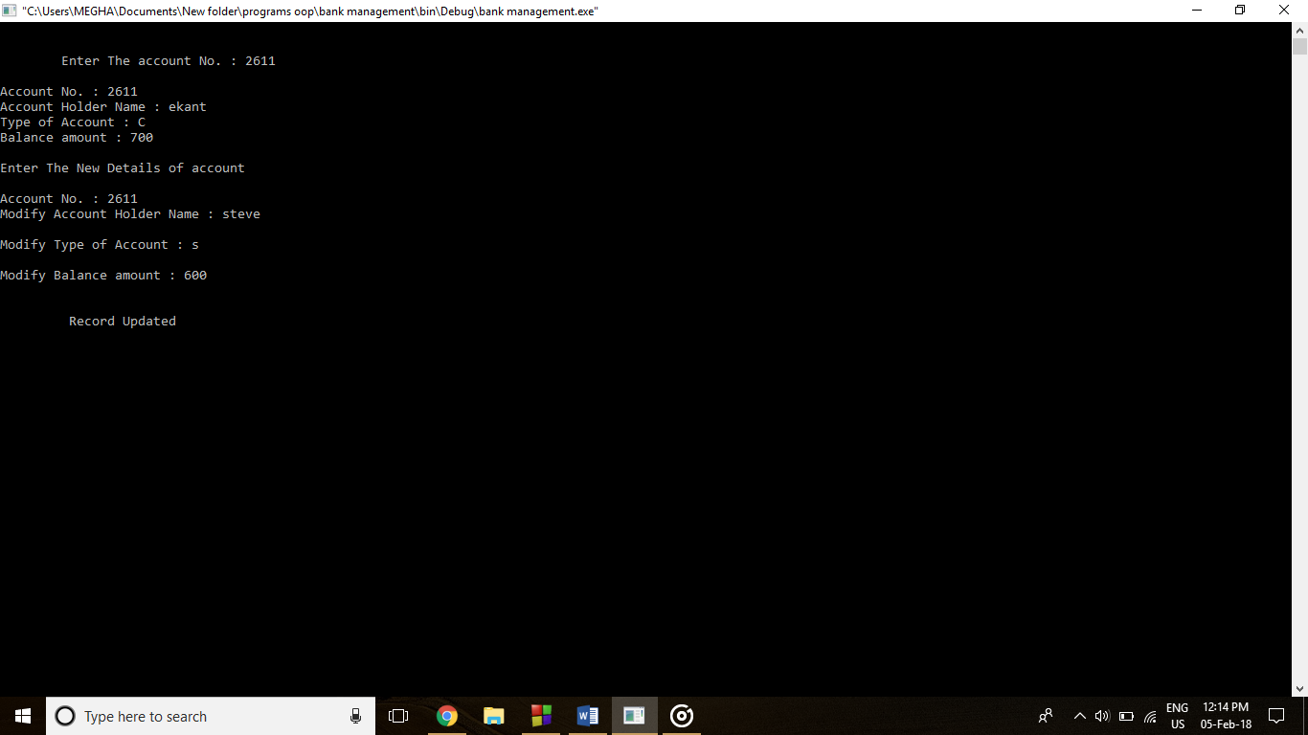

[SCREEN SHOT 9]

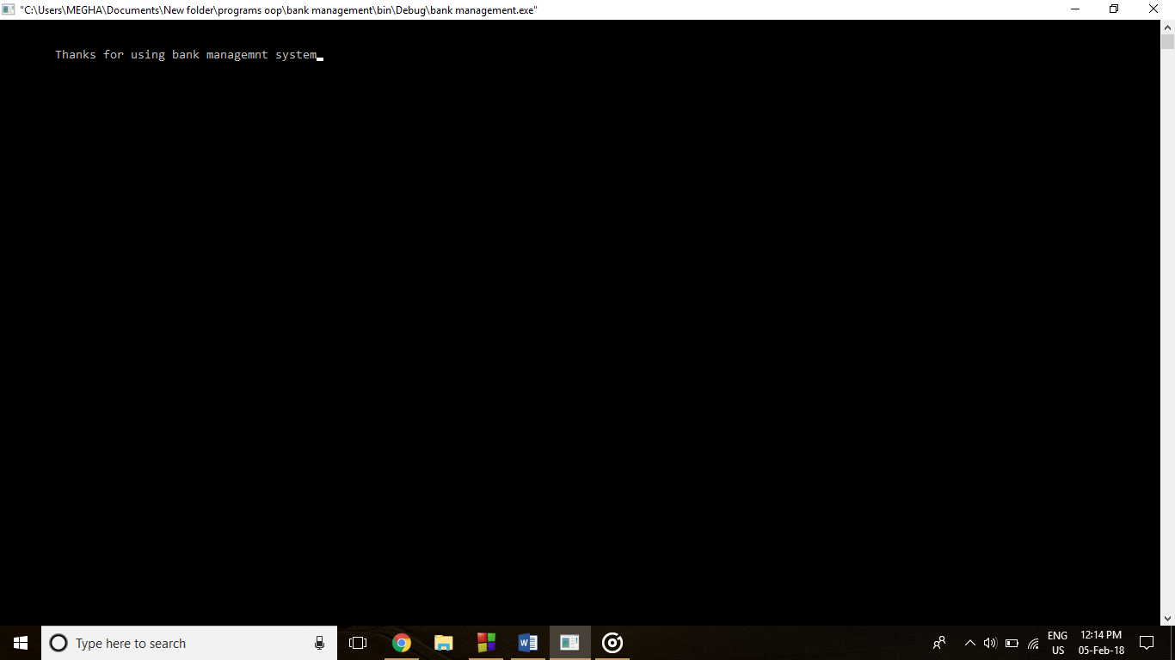

***Source Code :(***Prestandard C++)

//***************************************************************

// HEADER FILE USED IN PROJECT

//****************************************************************

#include<fstream.h>

#include<ctype.h>

#include<iomanip.h>

#include<conio.h>

#include<stdio.h>

//***************************************************************

// CLASS USED IN PROJECT

//****************************************************************

class account

{

int acno;

char name[50];

int deposit;

char type;

public:

void create_account(); //function to get data from user

void show_account(); //function to show data on screen

void modify(); //function to get new data from user

void dep(int); //function to accept amount and add to balance amount

void draw(int); //function to accept amount and subtract from balance amount

void report(); //function to show data in tabular format

int retacno(); //function to return account number

int retdeposit(); //function to return balance amount

char rettype(); //function to return type of account

}; //class ends here

void account::create_account()

{

cout<<"\nEnter The account No.";

cin>>acno;

cout<<"\n\nEnter The Name of The account Holder : ";

gets(name);

cout<<"\nEnter Type of The account (C/S) : ";

cin>>type;

type=toupper(type);

cout<<"\nEnter The Initial amount(>=500 for Saving and >=100 for current ) : ";

cin>>deposit;

cout<<"\n\n\nAccount Created..";

}

void account::show_account()

{

cout<<"\nAccount No. : "<<acno;

cout<<"\nAccount Holder Name : ";

cout<<name;

cout<<"\nType of Account : "<<type;

cout<<"\nBalance amount : "<<deposit;

}

void account::modify()

{

cout<<"\nThe account No."<<acno;

cout<<"\n\nEnter The Name of The account Holder : ";

gets(name);

cout<<"\nEnter Type of The account (C/S) : ";

cin>>type;

type=toupper(type);

cout<<"\nEnter The amount : ";

cin>>deposit;

}

void account::dep(int x)

{

deposit+=x;

}

void account::draw(int x)

{

deposit-=x;

}

void account::report()

{

cout<<acno<<setw(10)<<" "<<name<<setw(10)<<" "<<type<<setw(6)<<deposit<<endl;

}

int account::retacno()

{

return acno;

}

int account::retdeposit()

{

return deposit;

}

char account::rettype()

{

return type;

}

//***************************************************************

// function declaration

//****************************************************************

void write_account(); //function to write record in binary file

void display_sp(int); //function to display account details given by user

void modify_account(int); //function to modify record of file

void delete_account(int); //function to delete record of file

void display_all(); //function to display all account details

void deposit_withdraw(int, int); // function to desposit/withdraw amount for given account

void intro(); //introductory screen function

//***************************************************************

// THE MAIN FUNCTION OF PROGRAM

//****************************************************************

int main()

{

char ch;

int num;

clrscr();

intro();

do

{

clrscr();

cout<<"\n\n\n\tMAIN MENU";

cout<<"\n\n\t01. NEW ACCOUNT";

cout<<"\n\n\t02. DEPOSIT AMOUNT";

cout<<"\n\n\t03. WITHDRAW AMOUNT";

cout<<"\n\n\t04. BALANCE ENQUIRY";

cout<<"\n\n\t05. ALL ACCOUNT HOLDER LIST";

cout<<"\n\n\t06. CLOSE AN ACCOUNT";

cout<<"\n\n\t07. MODIFY AN ACCOUNT";

cout<<"\n\n\t08. EXIT";

cout<<"\n\n\tSelect Your Option (1-8) ";

cin>>ch;

clrscr();

switch(ch)

{

case '1':

write_account();

break;

case '2':

cout<<"\n\n\tEnter The account No. : "; cin>>num;

deposit_withdraw(num, 1);

break;

case '3':

cout<<"\n\n\tEnter The account No. : "; cin>>num;

deposit_withdraw(num, 2);

break;

case '4':

cout<<"\n\n\tEnter The account No. : "; cin>>num;

display_sp(num);

break;

case '5':

display_all();

break;

case '6':

cout<<"\n\n\tEnter The account No. : "; cin>>num;

delete_account(num);

break;

case '7':

cout<<"\n\n\tEnter The account No. : "; cin>>num;

modify_account(num);

break;

case '8':

cout<<"\n\n\tThanks for using bank managemnt system";

break;

default :cout<<"\a";

}

getch();

}while(ch!='8');

return 0;

}

//***************************************************************

// function to write in file

//****************************************************************

void write_account()

{

account ac;

ofstream outFile;

outFile.open("account.dat",ios::binary|ios::app);

ac.create_account();

outFile.write((char *) &ac, sizeof(account));

outFile.close();

}

//***************************************************************

// function to read specific record from file

//****************************************************************

void display_sp(int n)

{

account ac;

int flag=0;

ifstream inFile;

inFile.open("account.dat",ios::binary);

if(!inFile)

{

cout<<"File could not be open !! Press any Key...";

return;

}

cout<<"\nBALANCE DETAILS\n";

while(inFile.read((char *) &ac, sizeof(account)))

{

if(ac.retacno()==n)

{

ac.show_account();

flag=1;

}

}

inFile.close();

if(flag==0)

cout<<"\n\nAccount number does not exist";

}

//***************************************************************

// function to modify record of file

//****************************************************************

void modify_account(int n)

{

int found=0;

account ac;

fstream File;

File.open("account.dat",ios::binary|ios::in|ios::out);

if(!File)

{

cout<<"File could not be open !! Press any Key...";

return;

}

while(File.read((char *) &ac, sizeof(account)) && found==0)

{

if(ac.retacno()==n)

{

ac.show_account();

cout<<"\n\nEnter The New Details of account"<<endl;

ac.modify();

int pos=(-1)*sizeof(account);

File.seekp(pos,ios::cur);

File.write((char *) &ac, sizeof(account));

cout<<"\n\n\t Record Updated";

found=1;

}

}

File.close();

if(found==0)

cout<<"\n\n Record Not Found ";

}

//***************************************************************

// function to delete record of file

//****************************************************************

void delete_account(int n)

{

account ac;

ifstream inFile;

ofstream outFile;

inFile.open("account.dat",ios::binary);

if(!inFile)

{

cout<<"File could not be open !! Press any Key...";

return;

}

outFile.open("Temp.dat",ios::binary);

inFile.seekg(0,ios::beg);

while(inFile.read((char *) &ac, sizeof(account)))

{

if(ac.retacno()!=n)

{

outFile.write((char *) &ac, sizeof(account));

}

}

inFile.close();

outFile.close();

remove("account.dat");

rename("Temp.dat","account.dat");

cout<<"\n\n\tRecord Deleted ..";

}

//***************************************************************

// function to display all accounts deposit list

//****************************************************************

void display_all()

{

account ac;

ifstream inFile;

inFile.open("account.dat",ios::binary);

if(!inFile)

{

cout<<"File could not be open !! Press any Key...";

return;

}

cout<<"\n\n\t\tACCOUNT HOLDER LIST\n\n";

cout<<"====================================================\n";

cout<<"A/c no. NAME Type Balance\n";

cout<<"====================================================\n";

while(inFile.read((char *) &ac, sizeof(account)))

{

ac.report();

}

inFile.close();

}

//***************************************************************

// function to deposit and withdraw amounts

//****************************************************************

void deposit_withdraw(int n, int option)

{

int amt;

int found=0;

account ac;

fstream File;

File.open("account.dat", ios::binary|ios::in|ios::out);

if(!File)

{

cout<<"File could not be open !! Press any Key...";

return;

}

while(File.read((char *) &ac, sizeof(account)) && found==0)

{

if(ac.retacno()==n)

{

ac.show_account();

if(option==1)

{

cout<<"\n\n\tTO DEPOSITE AMOUNT ";

cout<<"\n\nEnter The amount to be deposited";

cin>>amt;

ac.dep(amt);

}

if(option==2)

{

cout<<"\n\n\tTO WITHDRAW AMOUNT ";

cout<<"\n\nEnter The amount to be withdraw";

cin>>amt;

int bal=ac.retdeposit()-amt;

if((bal<500 && ac.rettype()=='S') || (bal<1000 && ac.rettype()=='C'))

cout<<"Insufficience balance";

else

ac.draw(amt);

}

int pos=(-1)* sizeof(ac);

File.seekp(pos,ios::cur);

File.write((char *) &ac, sizeof(account));

cout<<"\n\n\t Record Updated";

found=1;

}

}

File.close();

if(found==0)

cout<<"\n\n Record Not Found ";

}

//***************************************************************

// INTRODUCTION FUNCTION

//****************************************************************

void intro()

{

cout<<"\n\n\n\t BANK";

cout<<"\n\n\tMANAGEMENT";

cout<<"\n\n\t SYSTEM";

cout<<"\n\n\n\nMADE BY :Khushdeep Tanwar(2632454)";

cout<<"\n\nSCHOOL : Blue Bells Model School";

getch();

}

//***************************************************************

// END OF PROJECT

//***************************************************************

BIBLIOGRAPHY

1. “Accelerated C++ : Practical programming by example” By Andrew Koenig and Barbara E. Moo

2. “Let Us C++” By Yashwant P.Kanetkar

3.”C++:The complete reference (4’th Ed.)” By Herbert Schildt